Yr 12 General Integrated Science
TASK 3 – Effect of salinity on plant growth
The increasing salinity of our rivers and land is of real concern. As we cut down trees and put more fertilisers in our soils we tend to increase the percentage of salt in water and on land. Your task is to investigate the effect of different levels of salt on the growth of plants.
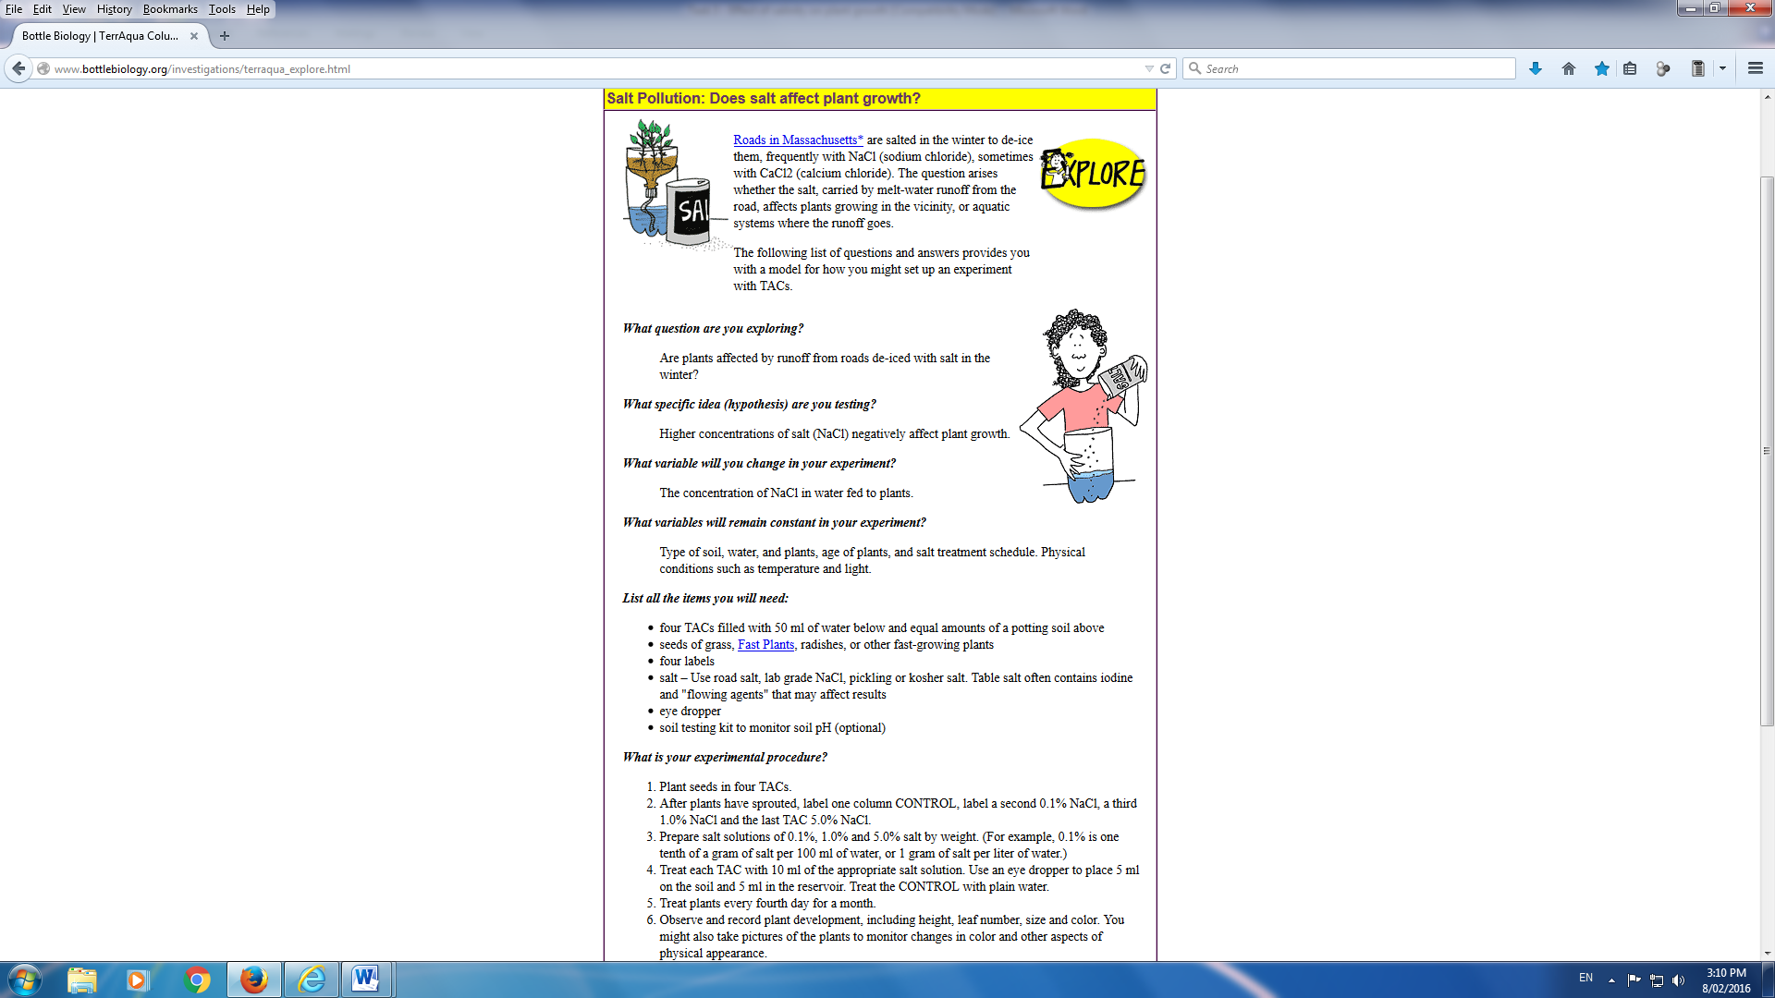
Experiment and find out how varying degrees of salinity affect plants!
YOU WILL NEED
- Several small pots to grow your plants in. At least half four per group.
- Gravel or small stones to increase good drainage in bottom of pot.
- Potting mix or garden soil.
- Seeds, such as beans, or tomato (something easy to grow).
- Saline solution of different concentrations (0.05% ; 0.1% ; 0.5% and 1%).
- A warm, light area to grow the plants, protected from pests.
METHOD
- Put a shallow layer of gravel/stones in the bottom of each pot, then top up with soil, until about 3cm from the top of the pot.
- Press 3 or 4 seeds into each pot of soil, at depth suggested for your type of seed (a cm or so will probably do) and push soil back over hole, and firm down.
- Carefully water one pot with plain water, without disturbing the seed. This is your 'control' and will help you judge the reactions of the other plants compared with their normal growth pattern.
- Prepare salt and water solutions, ranging from 0.05 – 1.0%.
- Carefully water each pot, with the same amount, of a different solution.
- Keep moist, but not soggy.
- As the plants appear- or not- record what you notice, every day. Take a photo each day, if you can, to help better track their progress.
Due Date: Friday Week 7
CONSIDER THESE QUESTIONS...
What do you notice in the first few days? After a while?
What do you think is happening and why?
How does your experiment relate to real world problems?
What could be done to try to lessen the problems?
Are any of these things being done?

